By email
18 September 2019
Shed 39, 2 Fryatt Quay
Pipitea, Wellington 6011
PO Box 11646
Manners Street
Wellington 6142
T 04 384 5708
F 04 385 6960
www.gw.govt.nz
File Ref: OIAP-2-990
Tony Randle
fyi-request-9099-b48056b9@requests.fyi.org.nz
Dear Mr Randle
Request for information 2019-250
Official information complaint – Ombudsman’s Ref 498926
On 22 May 2019 Greater Wellington Regional Council (GWRC) was advised that the Ombudsman was investigating a complaint from you about our decision on your request for official information (2018-341).
On 26 November 2018, you requested from GWRC, in part:
3) Can I please have a copy of the monthly rail PTOM contract operating cost paid to TransDev since the rail service was taken over by TransDev under PTOM contract?
…
6) Can I please have a copy of the monthly bus PTOM contract operating cost paid to bus operators for each PTOM bus unit for each month since bus services were taken over by various bus operators under PTOM contracts?
GWRC responded on 20 December 2018 advising for both points 3 and 6 of your request:
Under the performance-based contracts, the payments to the operators are subject to an obligation of confidence. This information has been withheld in accordance with section 7(2)(b)(ii) of the Local Government Official Information and Meetings Act 1987 on the ground that releasing this information would be likely to unreasonably prejudice the commercial position of the operator in a competitive market.
Following your complaint about our decision on your request for official information (2018-341) the Ombudsman advised that if GWRC can resolve the complaint with you, there would be no need for an investigation.
Following consultation with operators of bus and rail services GWRC has decided to release under the Local Government Official Information and Meetings Act 1987 the monthly payments made to the operators under the Public Transport Operating Model (PTOM) contracts. This information is contained in Attachment 1- PTOM units contract payments.
I believe that this provides you with the information requested and resolves the complaint.
If you have any concerns with the decision(s) referred to in this letter, you have the right to request an investigation and review by the Ombudsman under section 27(3) of the Local Government Official Information and Meetings Act 1987.

Yours sincerely
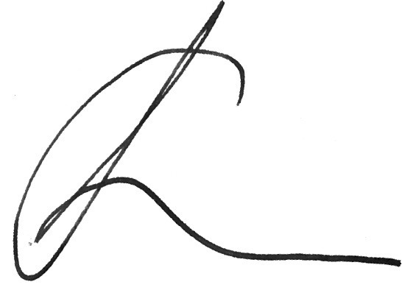
Greg Pollock
General Manager, Public Transport

