28 March 2018

Will

Public

By email: fyi-request-7420-87ee5665@requests.fyi.org.nz

Dear Sir

**Information Request** – **F2496594 - 263 James Fletcher Drive, Favona**

I refer to your official information request dated 12 March 2018 regarding **F2496594 - 263 James Fletcher Drive, Favona.**

In accordance with the provisions of the Official Information Act 1982, I *enclose* the information you requested.

Yours sincerely

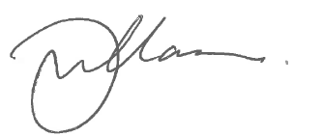

Gary Williamson

PP Kerry Gregory

Fire Region Manager

encl.