When replying please quote: 7706449

4 May 2018

Innovation Expert
fyi-request-7340-17a08123@requests.fyi.org.nz

Dear Sir/Madam

LGOIMA request – 27 April 2018

Please find below the Council’s response to your request (27 April) to “provide a copy of this legal opinion as the ‘gist’ or content has been publicly disclosed, creating an implied waiver of legal privilege”.

In Council’s opinion there has been no implied waiver of legal privilege.

Mayor Holdom email dated 29 January 2018
The first part that has been bolded in Mayor Holdom's email states: “In terms of the legal position, a right of renewal was originally included in the 1983 lease and was exercised in July 2002”. That part of the email simply states what is contained in the lease – it is not legal advice.

In respect of the second part that has been bolded "I have been advised there is nothing to suggest the right of renewal is perpetual"; you have made an assumption that the Mayor is referencing the legal opinion.

The requirement for waiver of legal privilege requires the client (in this instance the Council) to “voluntarily disclose a significant part of the legal advice”. On the assumption that the Mayor was referencing the legal opinion then it is the Council’s opinion that disclosure of a significant part of the legal advice has not occurred.

Alan Bird email dated 7 February 2018
“We have a legal opinion that confirms that position.”

The requirement for waiver of legal privilege requires the client (in this instance the Council) to “voluntarily disclose a significant part of the legal advice”. It is the Council’s opinion that Mr Bird’s email does not disclose a significant part of the legal advice and accordingly an implied waiver of legal privilege has not occurred.

The Council relies on section 7(2)(g) of the Local Government Official Information and Meetings Act 1987 to withhold all legal advice on this matter.

You have the right to make a complaint to the Ombudsman in respect of this decision. Information about how to make a complaint is available at www.ombudsman.parliament.nz or Freephone 0800 802 602.

Yours faithfully

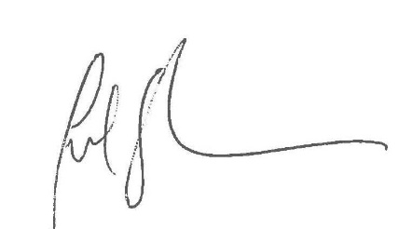

Julie Straka
GOVERNANCE LEAD

