19 February 2018

Richard Bollard
Fisher and Paykel Appliances

By email: fyi-request-7305-2a1d1a93@requests.fyi.org.nz

Dear Sir
Information Request – F2455653 - 10 Bond Street, Grey Lynn, Auckland
I refer to your official information request dated 19 February 2018 regarding F2455653 - 10 Bond Street, Grey Lynn, Auckland.

In accordance with the provisions of the Official Information Act 1982, I enclose the information you requested.

Yours sincerely

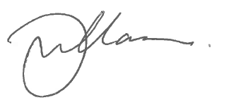

Gary Williamson
PP Kerry Gregory
Fire Region Manager

encl.

