26 October 2017

Richard
Public

By email: fyi-request-6706-2e3aa1bb@requests.fyi.org.nz

Dear Sir
Information Request – Structure Fires in North Shore Incl 832, 8310, 822, 9219 and 812
I refer to your official information request dated 17 October 2017 regarding Structure Fires in North Shore Incl 832, 8310, 822, 9219 and 812.

In accordance with the provisions of the Official Information Act 1982, I enclose the information you requested.

Yours sincerely

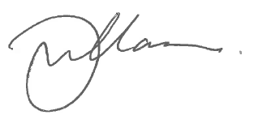

Gary Williamson
Business Services Manager

encl.

