14 August 2017

Richard
Public

fyi-request-6401-feffd80c@requests.fyi.org.nz

Dear Richard

Information Request – F2361175 - 18 Neville Street, Warkworth

I am writing to acknowledge receipt of your information request, received on 14 August 2017, regarding: F2361175 - 18 Neville Street, Warkworth.

In accordance with section 15 of the Official Information Act 1982 we will try to respond to your request as soon as possible and in any event no later than 20 working days after the day your request was received. If we are unable to respond to your request by then, we will notify you of an extension of that timeframe.

We will contact you if we require further information to clarify, or to enable us to process, your request. If any additional factors come to light which are relevant to your request, please do not hesitate to contact us so that these can be taken into account.

Yours sincerely

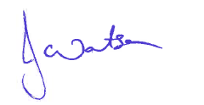
Jackie Watson
Regional Business Services Coordinator

