11 August 2017

Richard
Public

By email: fyi-request-6342-915dcab3@requests.fyi.org.nz

Dear Sir
Information Request – F23553-7 - 26 Putiki Street, Grey Lynn, Auckland
I refer to your official information request dated [Date received] regarding F23553-7 - 26 Putiki Street, Grey Lynn, Auckland.

In accordance with the provisions of the Official Information Act 1982, I enclose the information you requested.

Yours sincerely

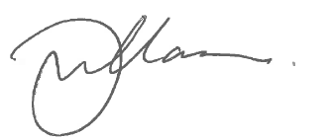

Gary Williamson
Business Services Manager

encl.

