11 August 2017

Jay

Public

By email: fyi-request-6318-7d6abcb3@requests.fyi.org.nz

Dear Sir

**Information Request** – **F2354027 - 13 Tavern Road, Silverdale**

I refer to your official information request dated 1 August 2017 regarding **F2354027 - 13 Tavern Road, Silverdale.**

In accordance with the provisions of the Official Information Act 1982, I *enclose* the information you requested.

Yours sincerely

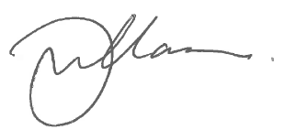

Gary Williamson

Business Services Manager

encl.