1 August 2017

Jay

Public

fyi-request-6318-7d6abcb3@requests.fyi.org.nz

Dear Sir

**Official Information Request - F2354030 - 1B Nile Road, Milford**

I refer to your official information request which was received on 01 August 2017. In accordance with the provisions of the Official Information Act 1982 I enclose copies of the information you requested.

On 1 July 2017, the New Zealand Fire Service Commission became **Fire and Emergency New Zealand** (Fire and Emergency).  Fire and Emergency is responsible for responding to requests for official information that were made to the Commission and not determined before 1 July 2017.

Yours sincerely

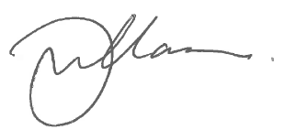

Gary Williamson

Business Services Manager