24 July 2017

Steven
Public

fyi-request-6260-a09a144a@requests.fyi.org.nz

Dear Sir

Official Information Request - F2346910 - 135 Forrest Hill Road, Forrest Hill

I refer to your official information request which was received on 24 July 2017. In accordance with the provisions of the Official Information Act 1982 I enclose copies of the information you requested.

On 1 July 2017, the New Zealand Fire Service Commission became Fire and Emergency New Zealand (Fire and Emergency). Fire and Emergency is responsible for responding to requests for official information that were made to the Commission and not determined before 1 July 2017.

Yours sincerely

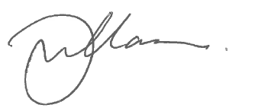

Gary Williamson
Business Services Manager

