7 July 2017

Steven
Public

fyi-request-6146-6f90556b@requests.fyi.org.nz

Dear Steven

Information Request – F2338094 - Walmsley Road, Otahuhu
This letter is to acknowledge receipt of your information request, received on 07 July 2017, regarding: F2338094 - Walmsley Road, Otahuhu.

Section 15 of the Official Information Act 1982 states requests should be responded to “as soon as reasonably practicable, and in any case not later than 20 working days after the day on which the request is received” – although this timeframe may be extended in certain circumstances.

Yours sincerely

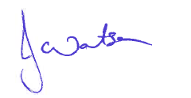
Jackie Watson
Regional Business Services Coordinator

