29 June 2017

Steven
Public

fyi-request-6086-0c688e43@requests.fyi.org.nz

Dear Steven

Information Request – F2333436 - 2-6 Airport Road, Whenuapai

This letter is to acknowledge receipt of your information request, received on 29 June 2017, regarding: F2333436 - 2-6 Airport Road, Whenuapai.

Section 15 of the Official Information Act 1982 states requests should be responded to “as soon as reasonably practicable, and in any case not later than 20 working days after the day on which the request is received” – although this timeframe may be extended in certain circumstances.

Yours sincerely

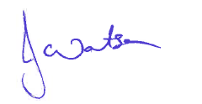
Jackie Watson
Regional Business Services Coordinator

