6 June 2017

Steven
Public

fyi-request-5911-6fa540e3@requests.fyi.org.nz

Dear Sir

Official Information Request - F2310721 - 121 Ferry Parade, Herald Island

I refer to your official information request which was received on 22 May 2017. In accordance with the provisions of the Official Information Act 1982 I enclose copies of the information you requested.

Yours sincerely
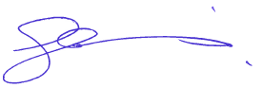

Glenn Menzies
Principal Advisor Fire Risk Management

