What’s the ideal road width for high quality protected safe cycle lanes?
July 2014

World class infrastructure for people on bikes travelling adjacent to traffic above 7500 vehicles per day moving at 50 km/h requires the provision of kerb protected, 2.2m wide cycle tracks. Ideally, cycle tracks are separated from the pedestrian footpath by a low kerb and also separated from adjacent parking by a kerb and 1.0m wide space for car doors and loading. Providing such infrastructure would require reconstructing much of the roadway and is therefore usually unaffordable unless the works can be coordinated with a major reconstruction which might arise once every 80-100 years.
Based on WCC’s Code of Practice for Land Development (2012), with the addition of best practice European protected cycle tracks, the ideal mid block cross section for a main road with traffic volumes above 7000 vehicles per day is 20.4m kerb to kerb. It has the following kerb to centreline (10.2m) layout:
- 2.2m wide (uni directional) bike lane to allow faster cyclists to pass slower people
- 1.0m wide buffer space between people on bikes and parked cars for car door opening and easy loading and unloading
- 2.5m wide parking lane if needed
- 3.5m wide general traffic lanes (additional lanes may be required for higher traffic volumes and/or bus priority lanes)
- 2.0m wide painted median for low volume turning and pedestrians (safety space).
Figure 1. Ideal mid block cross section with footpath separator (20.4m kerb to kerb)
The first compromise is to retro-fit the ideal widths to the existing roadway by using the existing kerbline as much as possible and substituting the kerb between the bike lane and parking lane with a painted line protected by bollards or similar features. This is cheaper than installing the ‘footpath’ separator between the bike lane and parking.
Figure 2. Ideal mid block cross section with bollard separator (20.4m kerb to kerb)
Where space is limited (nearly everywhere in Wellington) we squeeze ideal widths down to minimums if it is appropriate, taking account of the number and type of current and projected users, otherwise we must widen the roadway either by reducing footpath widths or taking adjacent property. In either case cost increases significantly. Squeezing ideal widths can compromise road safety and traffic efficiency.
Figure 3. Squeezed cross section parking both sides (14.4m kerb to kerb)
Figure 4: Squeezed cross section parking on one side (12.4m kerb to kerb)
If squeezing is not appropriate then we must prioritise the use of the road space. We apply the following hierarchy to the road space which places the need to move above the need to park (road space is for transport and only for storage when is not needed for another purpose):
- Footpath for the safe and efficient movement of pedestrians
- Traffic lanes for the safe and efficient movement of vehicles (sometimes special vehicle lanes are appropriate e.g. bus lanes)
- Bike lanes with appropriate safe buffer space for the safe and efficient movement of cyclists
- Car parking on one side to facilitate access to property and business
- Painted median for safer turning and pedestrians crossing the road way
- Parking on the other side to facilitate access to property and business.
Where volumes are high and there are many turning movements and there is higher demand to cross the road then it is appropriate to prioritise the provision of a painted median which provides safety space over parking on both sides.
Island Bay case study
Applying these principles to The Parade in Island Bay, we see the following.
The widest part of The Parade is north of Reef St and is 16.0m kerb to kerb. It has the following kerb to centreline (8.0m) layout with parking preserved on both sides:
- 1.8m wide (uni directional) bike lane to allow faster cyclists to pass slower people (squeezed slightly, 2.2m ideal)
- 1.0m wide buffer space between people on bikes and parked cars for car door opening and easy loading and unloading
- 2.0m wide parking lanes (squeezed to minimum, 2.5m ideal)
- 3.2m wide general traffic lanes (squeezed slightly, 3.5m ideal)
- no painted median (removed completely, 2.0m ideal).
Figure 5. The Parade north of Reef St (16.0m kerb to kerb)
Note that faster, more confident people on bikes may choose to continue to ride in the traffic lane but narrow space, outside car doors with relatively heavy traffic will make this uncomfortable so the cyclist will have to take the lane and this may delay motorised traffic.
However, much of the Parade is narrower than the 16.0m north of Reef St. In these narrower sections we squeeze the driving lane then the buffer space right down to minimum widths of 3.0m and 0.6m respectively:
- A 0.6m wide buffer space for car doors means when a car door is fully open there’s a 0.4m encroachment into the cycle lane but a careful cyclist can still pass an open car door in the remaining 1.4m of space in the bike lane. This should be OK when bike volumes, parking turnover and to a lesser extent parking occupancy are low.

- 3.0m wide general traffic lanes are tight but allow wider trucks or buses to pass carefully. This is considered OK in people friendly urban environments where we want traffic calmed streets and is a relatively common condition on many Wellington streets (e.g. parts of Adelaide Rd, Tinakori Rd, The Terrace, Tory St, Constable St). It is also consistent with UK guidance in the Manual For Streets 2 (2010) and Draft London Cycling Design Standards (2014).
Figure 6. The Parade typical cross section (14.8m kerb to kerb)
North of Humber St (a section 550m long) we’ve had to squeeze the cycle lane further (down to 1.4m) because space is even more limited being just 14.0m kerb to kerb. The tightness means the safe riding space past an open car door is at the minimum 1.0m so all road users will have to take extra care at busy times. Alternatively we can move a kerbline but often at high cost due to service and drainage requirements. We don’t think this is justified for The Parade at this time as safety risks are low because cycle numbers are relatively light, car parking is not fully occupied most of the time and parking turnover rates are low in the residential sections.

Figure 7. The Parade north of Humber St cross section (14.0m kerb to kerb)
Near Medway St our draft plans show wide bike lanes (2.0m) and minimum buffer space (0.6m):
Figure 8. The Parade near Medway St draft cross section (15.2m kerb to kerb)
This section is adjacent to the library and the medical centre and has high parking turnover. We think wider buffer space (1.0m) is better as it allows easier access to parked cars so bike lanes are narrowed to 1.6m. Faster cyclists will still be able to pass slower ones by using part of the buffer space when car doors are not open.
Figure 9. The Parade near Medway St alternate cross section (15.2m kerb to kerb)
North of Dee St there isn’t enough space to allow parking on both sides within the existing kerb to kerb width. Parking can be accommodated on either side and we’ve shown it outside the residences which have no off-street parking.
Figure 10. The Parade north of Dee St cross section (13.2m kerb to kerb)
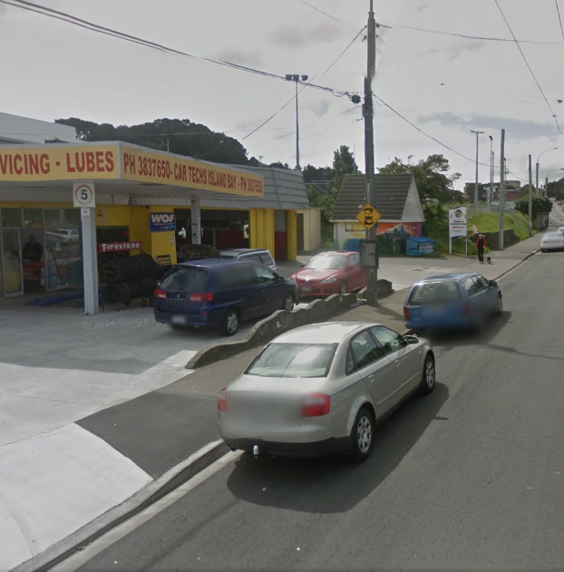
Figure 11. The Parade north of Dee St, west side looking north
We could widen the road by 2.0m for a length of about 50m at a cost of some $50,000 which will provide three more on-street car parks or we could designate part of the road reserve in front of the business as footpath and allow people on bikes to use the current footpath as a cycleway thereby allowing three cars to park next to the existing kerb. This option is likely to be considerably cheaper at around $10,000 for bollards and vehicle crossing changes.
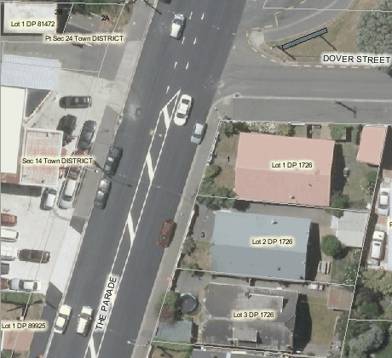
New 2.0m footpath with bollard protection in road reserve (currently operates as part of forecourt area)
3x on-street car parks retained
1.0m buffer space on footpath
1.8m bike only path on former footpath, requires adjacent heavy vehicle crossings to be made cycle friendly
Road boundary line
Figure 12. The Parade north of Dee St alternative low cost layout option

The following table sets out desirable and minimum widths for the various elements that make up a mid block carriageway cross section on busier collector/arterial roads.
Element | Ideal  Parking both sides | Minimum  Parking both sides | Minimum  Parking one side | Minimum  No parking | Sub standard  Not uncommon in Wellington
Traffic lane | 3.5m x2 | 3.0m x2 | 3.0m x2 | 3.0m x2 | <3.0m
Bike lane next to parking  Buffer space | 2.2m x2  1.0m x2 | 1.4m x2  0.6m x2 | 1.4m  0.6m
Parking | 2.5m x2 | 2.0m x2 | 2.0m x1 |  | 1.8m
Bike lane no parking  Buffer space |  |  | 1.7m  0.3m | 1.7m x2  0.3m x2
Median | 2.0m x1 | 0 | 0
Required width kerb to kerb | 20.4m | 14.0m | 12.0m | 10.0m | N/A

Removing the painted median is not without consequences. Painted medians provide:
- separation between oncoming vehicles
- wiggle room for traffic to pass cyclists and open cars doors
- a safe area for pedestrian to cross to in the middle of the road
- a safe area for vehicles turning into and out of adjacent property
- some traffic calming, speed reduction effect.
The absence of a median, especially next to a narrow traffic lane, will increase the risk of car door-vehicle conflicts and will make it more difficult for pedestrians to cross the carriageway. Vehicles turning right into properties may delay through traffic (this can cause nose to tail crashes and cause turners to accept smaller gaps if they feel pressured by following vehicles). Vehicles exiting properties may need to wait longer to find a suitable gap in both traffic streams.
On balance we believe providing high quality protected space for people on bikes who are vulnerable road users is a fair and reasonable trade off.

Cycle Network and Route Planning Guide, NZTA, 2004, page 35.
Code of Practice for Land Development, WCC, 2012, Table 1 Road Widths, page 57.
Collection of Cycle Concepts, Danish Road Directorate, 2000, page 73. And assuming the full effective width is cycle friendly. This means the channel – seal edge detail must be relatively smooth to allow the channel to be part of the usable area. If the edge detail is unfriendly then 0.3-0.4m more width is ideal.
Collection of Cycle Concepts, page 75. Ideally wider if parking passenger turnover is high.
Bike lanes need to be wide enough to allow cyclists to pass one another as their speed can vary greatly, much more so than motorised traffic. This will become more evident as electric bikes become more common.
Assuming the full effective width is cycle friendly. This means the channel – seal edge detail must be relatively smooth to allow the channel to be part of the usable area. If the edge detail is unfriendly then 0.3-0.4 more width is ideal.
Cycling Aspects of Austroads Guides 2014, Cyclist Envelope, figure 4.18, page 23.
The cost to remove a kerb and create a new one varies significantly depending on the length and area being changed. There is often also a need to relocate underground services, utility poles and adjust drainage provisions.
New Zealand research shows the presence of a painted median to reduce cycle related crashes by 37%. NZTA report 389, 2009, page 9.

