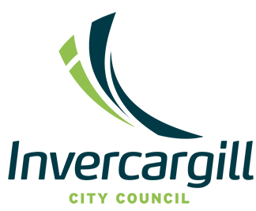

Independent Member- Water Committee
- Deputy Chair
- Shape the future of water services governance in Invercargill
- Strategic Leadership | Technical Expertise | Community Impact

About the Role:
Invercargill City Council are seeking an Independent Member with water services expertise to join the newly established Water Committee as Deputy Chair. This is a significant governance appointment at a pivotal time as Council moves from planning to implementation of its Water Services Delivery Plan (WSDP) under the Local Water Done Well framework.
The Water Committee provides governance oversight of Council’s responsibilities for drinking water, wastewater, and stormwater services. The Independent Member will play a key role in ensuring robust governance, compliance with legislative and regulatory requirements, strong stakeholder engagement, effective risk management and high-quality decision making.
This is a remunerated position with meetings held in the Council Chamber on the first Tuesday of each month at 9am.

What We’re Looking For
Candidates who reside in/are well connected into the Otago and Southland region are preferred. The successful candidate will bring a combination of:
- Water services expertise – drinking water, wastewater, stormwater systems, sector reforms, service delivery, infrastructure asset management, and regulatory frameworks
- Commercial acumen – particularly with commercial contracts, from a governance perspective
- Governance experience – demonstrated ability to chair particularly in regulated environments or managing infrastructure and capital investment; governance experience in the public sector
- Strategic leadership, communication and stakeholder engagement skills - to guide a business through establishment, change and transition
- Financial and risk management acumen – oversight of budgets, oversight of large infrastructure programmes and strategic risk mitigation
- Regulatory and legislative knowledge – some familiarity with relevant acts, legislation, Commerce Commission and Taumata Arowai standards
- Commitment to Te Tiriti partnership – supporting respectful engagement with Mana Whenua.

Why This Role Matters
This is a legacy opportunity to influence the future of water services in Invercargill. The successful appointee will work alongside Elected Members and Mana Whenua representatives to ensure robust governance and strategic leadership for essential community infrastructure.

About the Organisation:
Invercargill City Council is a progressive local authority committed to delivering high-quality services to its community. With the decision to retain local control of water services, ICC is establishing a new Water Services Entity that will operate as a financially ringfenced business unit, delivering water services with a commercial lens while remaining accountable to the community.

Culture:
At ICC, our values guide everything we do:
- Responsibility – We take ownership of decisions out outcomes.
- Above and Beyond – We take opportunities to go the extra mile.
- Respect – Everyone is important, as are their views.
- Positivity – We always look on the bright side of life.

