4 February 2026
08
Fall

RS Bicknell
fyi-request-31984-c92eb036@requests.fyi.org.nz

Tēnā koe RS Bicknell
Thank you for your Official Information Act 1982 (the Act) request, received 18 December 2025, asking for:
- An explanation as to why Mr Lesā was deemed suitable to be appointed to this position.
- All documents pertaining to Mr Lesā's appointment including a) any CVs, application forms, or statements or information supplied by Mr Lesā in the course of the appointment process b) any advice or reports produced by the Committee in the process of appointing Mr Lesā.
- A record of the total amount of funds paid by the Committee to Mr Lesā during his appointment.
- How many meetings Mr Lesā attended, and how many meetings he did not attend during his appointment.
- Any information/complaints/concerns pertaining to Mr Lesā raised with the Committee before, during, or after Mr Lesā's appointment.
Response
The response to your request is in Appendix 1.
If you have any additional queries please contact us at info@hqsc.govt.nz.
You have the right to seek an investigation and review by the Ombudsman of this decision under s 28(3) of the Act. Information about how to make a complaint is available at www.ombudsman.parliament.nz or by calling 0800 802 602.
Please note the Commission publishes some of its OIA responses on its website, after the response is sent. We will not publish your name, address, or contact details.
Nāku noa, nā
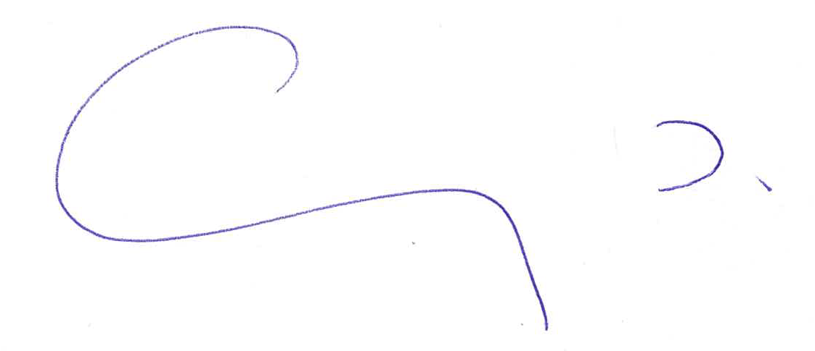

Professor Sunny Collings
Chief Executive
Health Quality & Safety Commission Te Tāhū Hauora

Appendix 1

- An explanation as to why Mr Lesā was deemed suitable to be appointed to this position.
Mr Lesā followed the standard process for appointments to the Commission’s mortality review committees, including submitting a CV and providing references, and was deemed to be an appropriate candidate on the basis of the material supplied and the reference checks undertaken.
- All documents pertaining to Mr Lesā's appointment including a) any CVs, application forms, or statements or information supplied by Mr Lesā in the course of the appointment process b) any advice or reports produced by the Committee in the process of appointing Mr Lesā.
Information still held by the Commission regarding Mr Lesā’s appointment is publicly available at https://fyi.org.nz/request/31684-fale-andrew-lesa-stuff-investigation-reveals-flawed-cv#incoming-128246

Some information is withheld under s9(2)(a) of the Act, to protect privacy, and under s18(e), that the information does not exist.

- A record of the total amount of funds paid by the Committee to Mr Lesā during his appointment.
The Commission’s records show that from 2016 – 2023 Mr Lesā was paid:
- $14,960 in meeting fees
- $117.91 in expense reimbursements
- How many meetings Mr Lesā attended, and how many meetings he did not attend during his appointment.
Attendance records for Mr Lesā show he attended 22 meetings and gave apologies for 5 meetings.
- Any information/complaints/concerns pertaining to Mr Lesā raised with the Committee before, during, or after Mr Lesā's appointment.
The Commission is not aware of any complaints or concerns raised with the Committee.

