Waitai Coastal-Burwood
Resident Associations
Boundary Maps Collation

Status | Name
Residents Association - Active | Aranui Community Trust
Residents Association - Active | Avondale Residents' Association
Residents Association - Active | Burwood East Residents' Association
Residents Association - Active | Dallington Residents Association
Residents Association - Active | New Brighton Residents Association
Residents Association - Active | North Beach Residents Association
Residents Association - Active | Parklands Residents Association
Residents Association - Active | Prestons Residents Association
Residents Association - Active | Southshore Residents Association
Residents Association - Active | Spencerville Residents Association
Residents Association - Active | Waimairi Beach Residents Association
Residents Association - In Recess | Anglesea South Neighbourhood Support
Residents Association - In Recess | Ascot / Freeville Residents Association
Residents Association - In Recess | Horseshoe Lake Residents Association
Residents Association - In Recess | Golf Links Residents Association
Residents Association - In Recess | Tumara Park Neighbours
Residents Association - In Recess | Waitakiri Residents Association
Residents Association - Not Council Recognised | South Brighton Residents Association
Residents Association - Informal and Not Council Recognised | Avondale Neighbours

Status: Residents Association – Active
Name: Aranui Community Trust
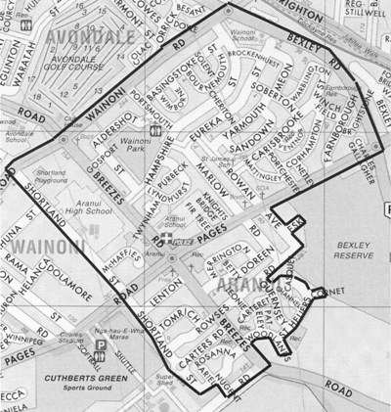

Status: Residents Association – Active
Name: Avondale Residents' Association
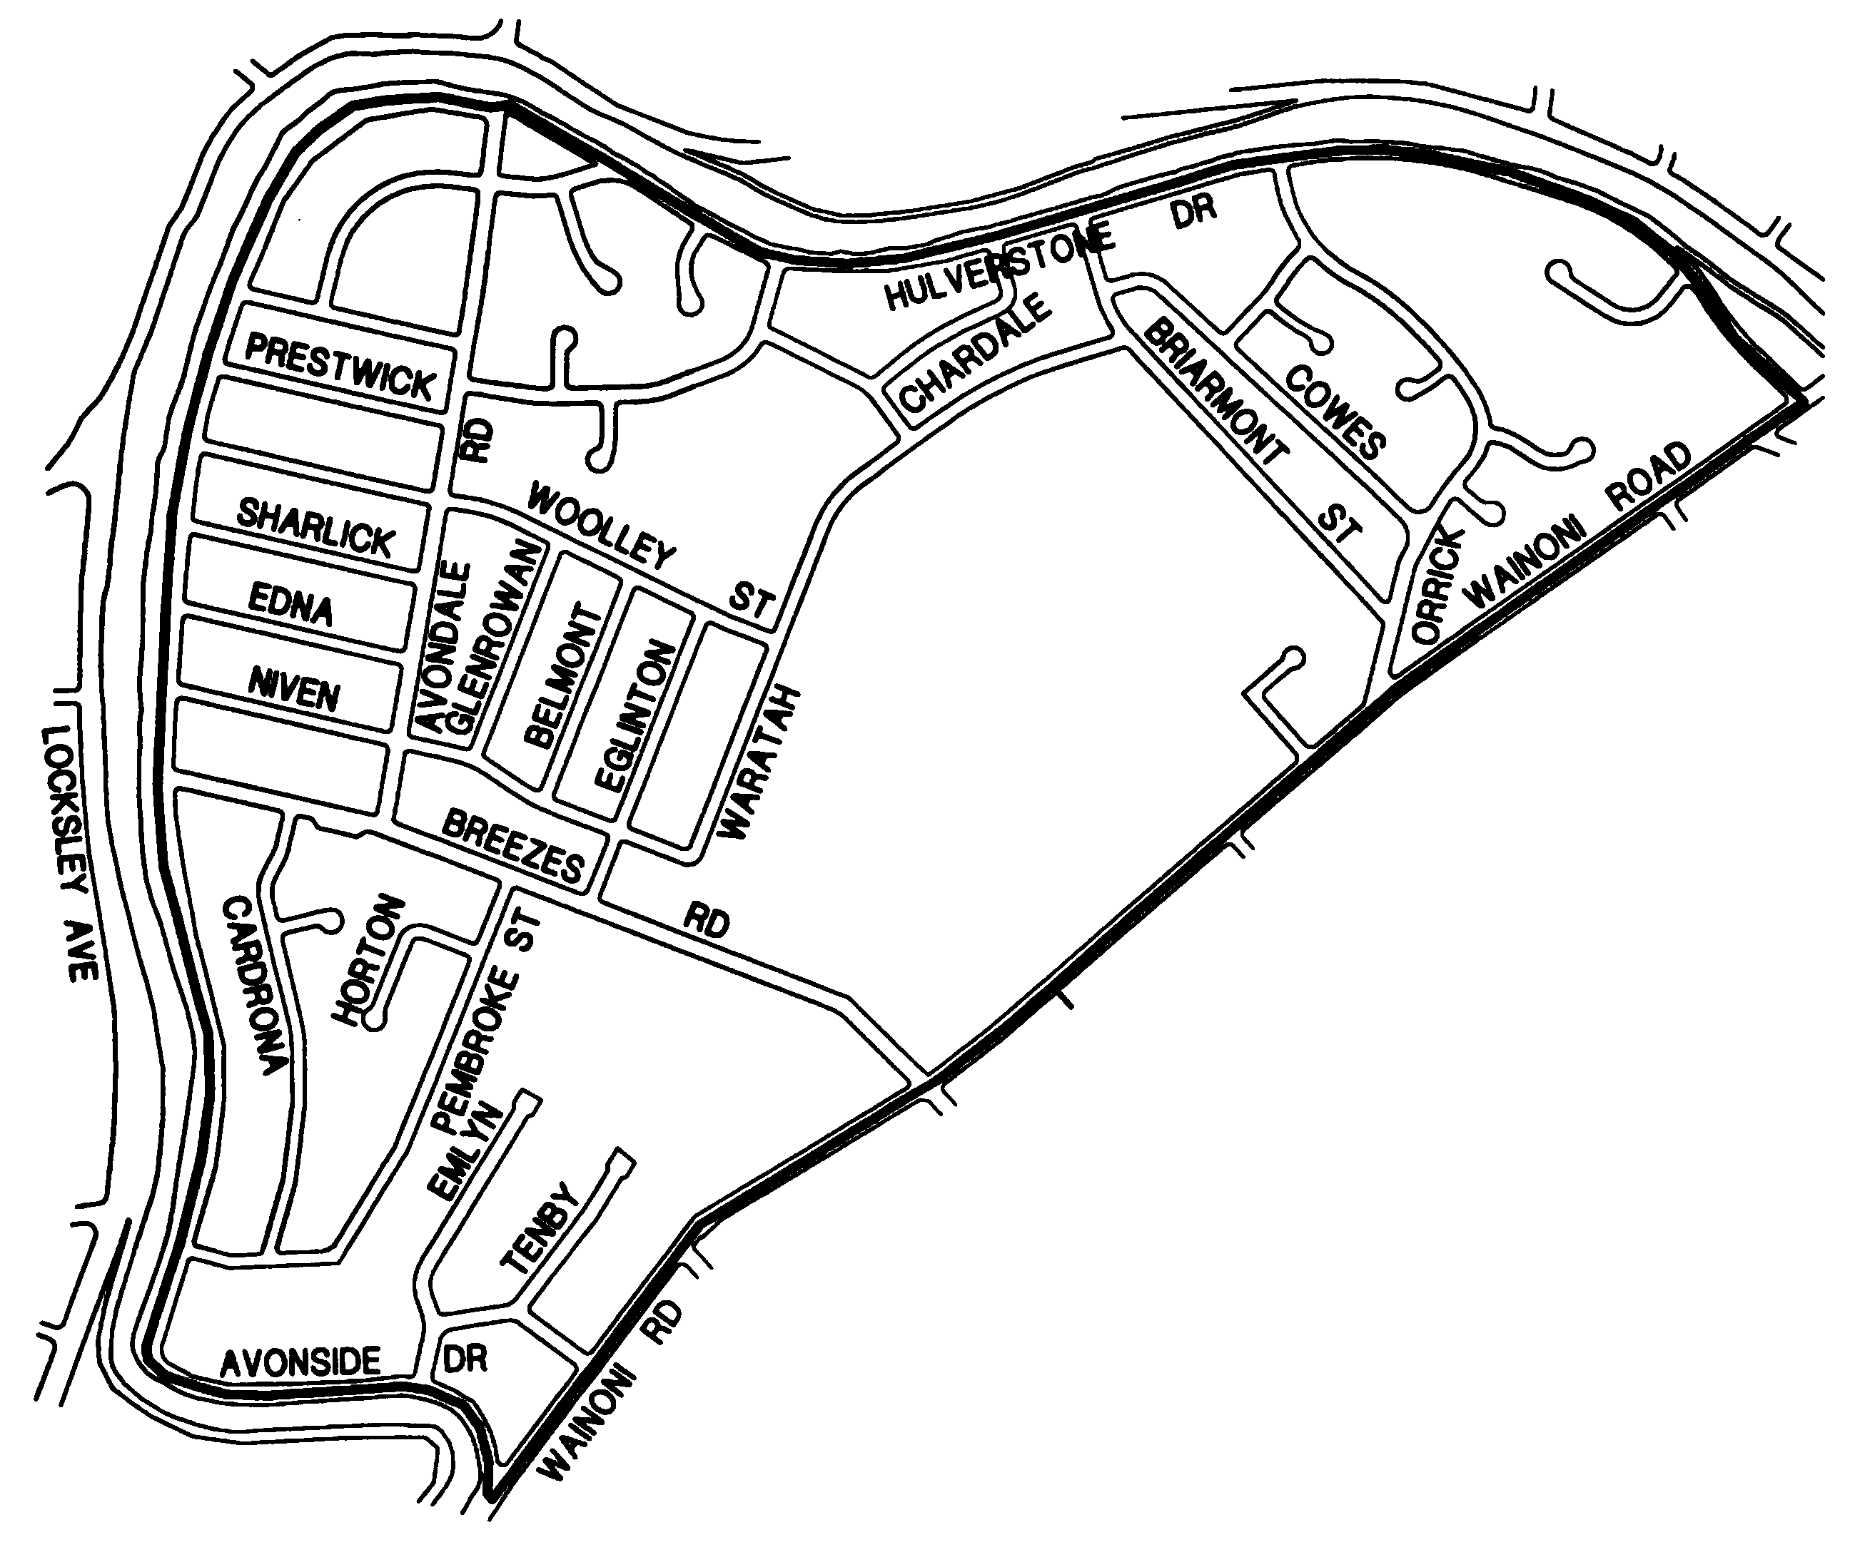

Status: Residents Association – Active
Name: Burwood East Residents' Association

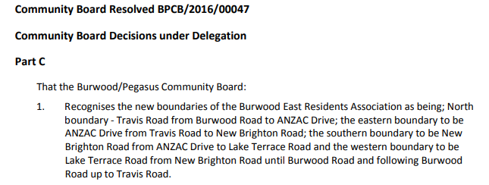
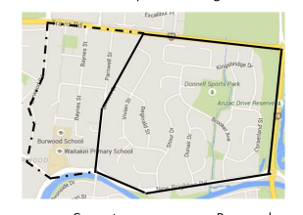

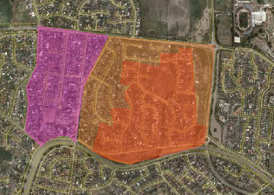

Status: Residents Association – Active
Name: Dallington Residents Association

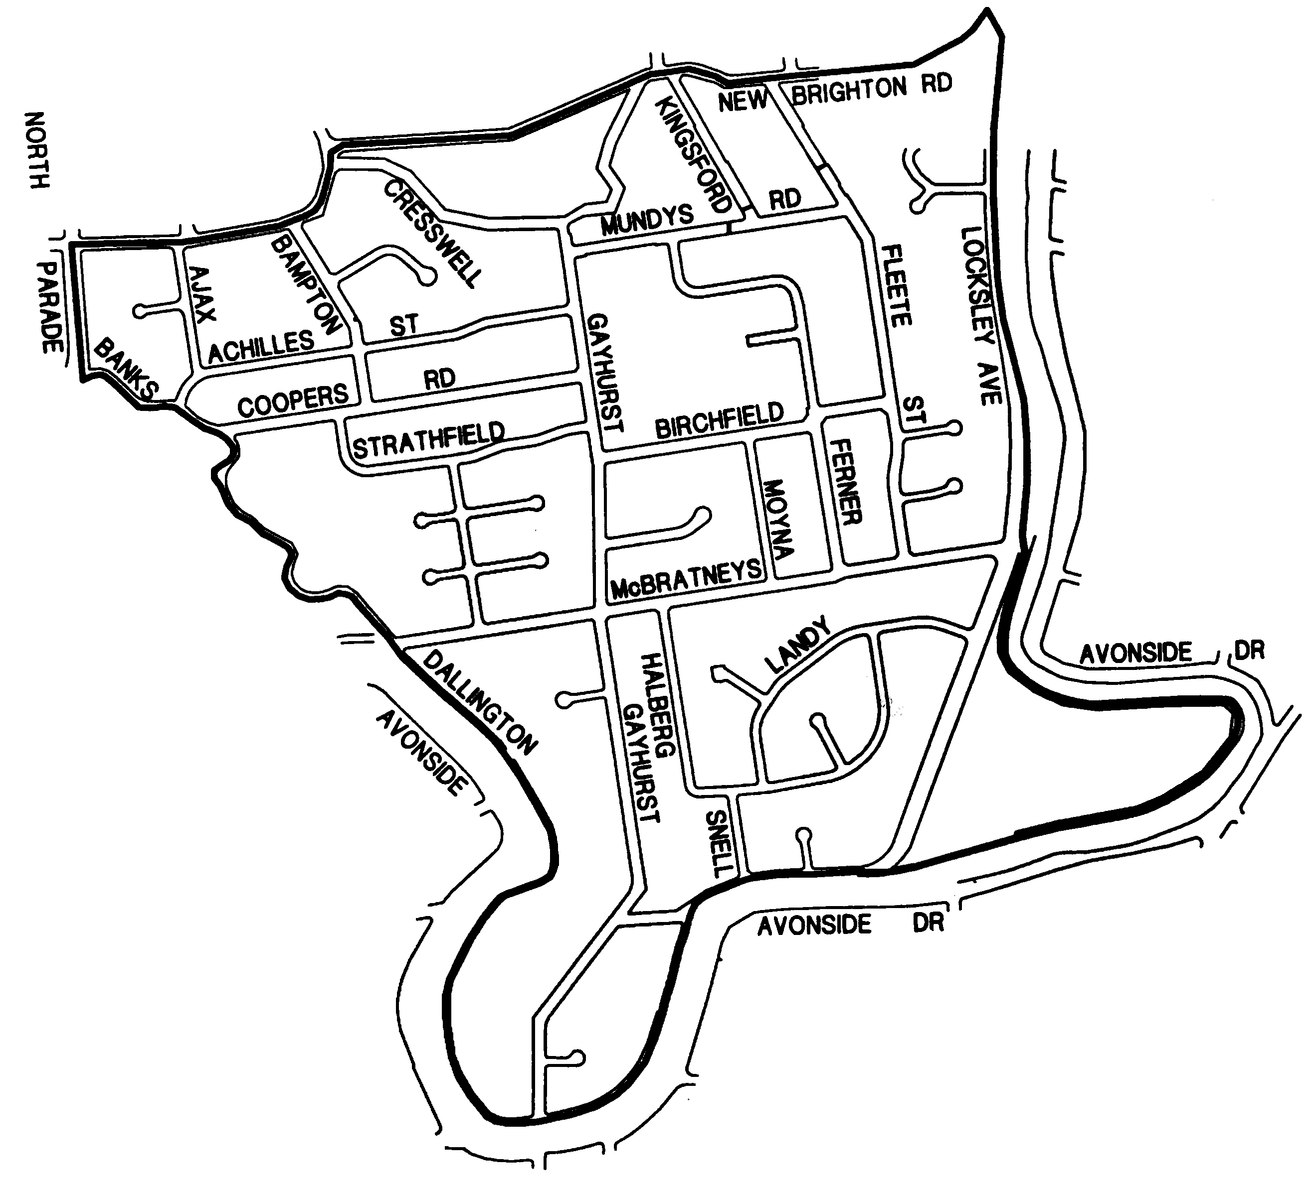

Status: Residents Association – Active
Name: New Brighton Residents Association

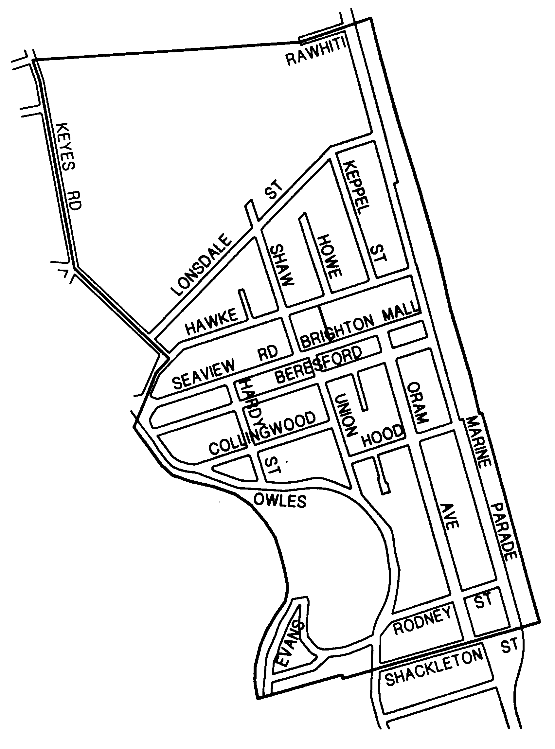

Status: Residents Association – Active
Name: North Beach Residents Association

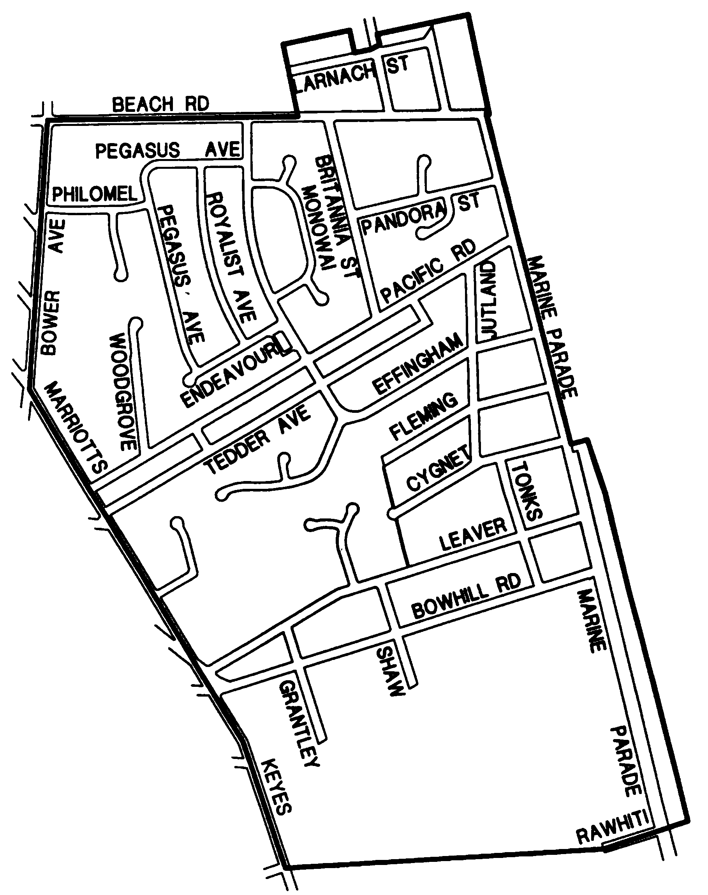

Status: Residents Association – Active
Name: Parklands Residents Association

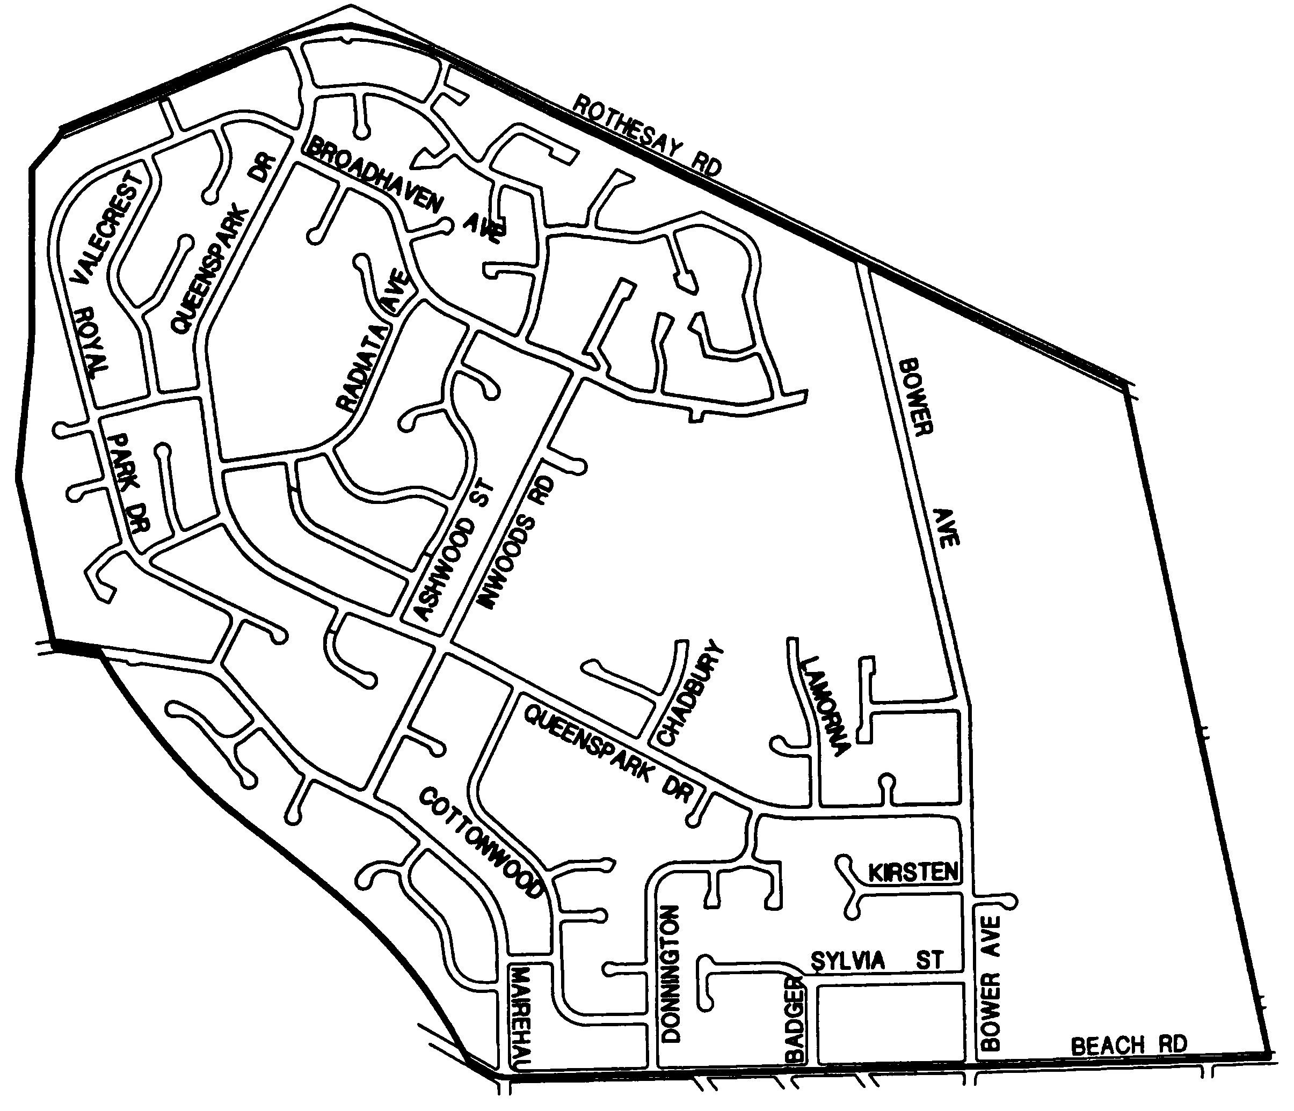

Status: Residents Association – Active
Name: Prestons Residents Association

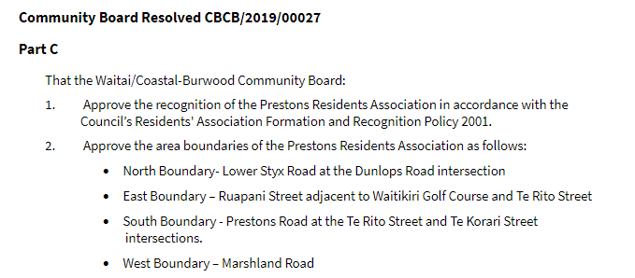
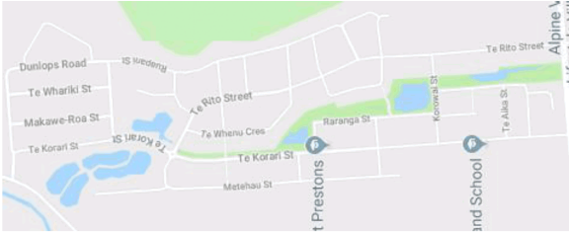

Status: Residents Association – Active
Name: Southshore Residents Association

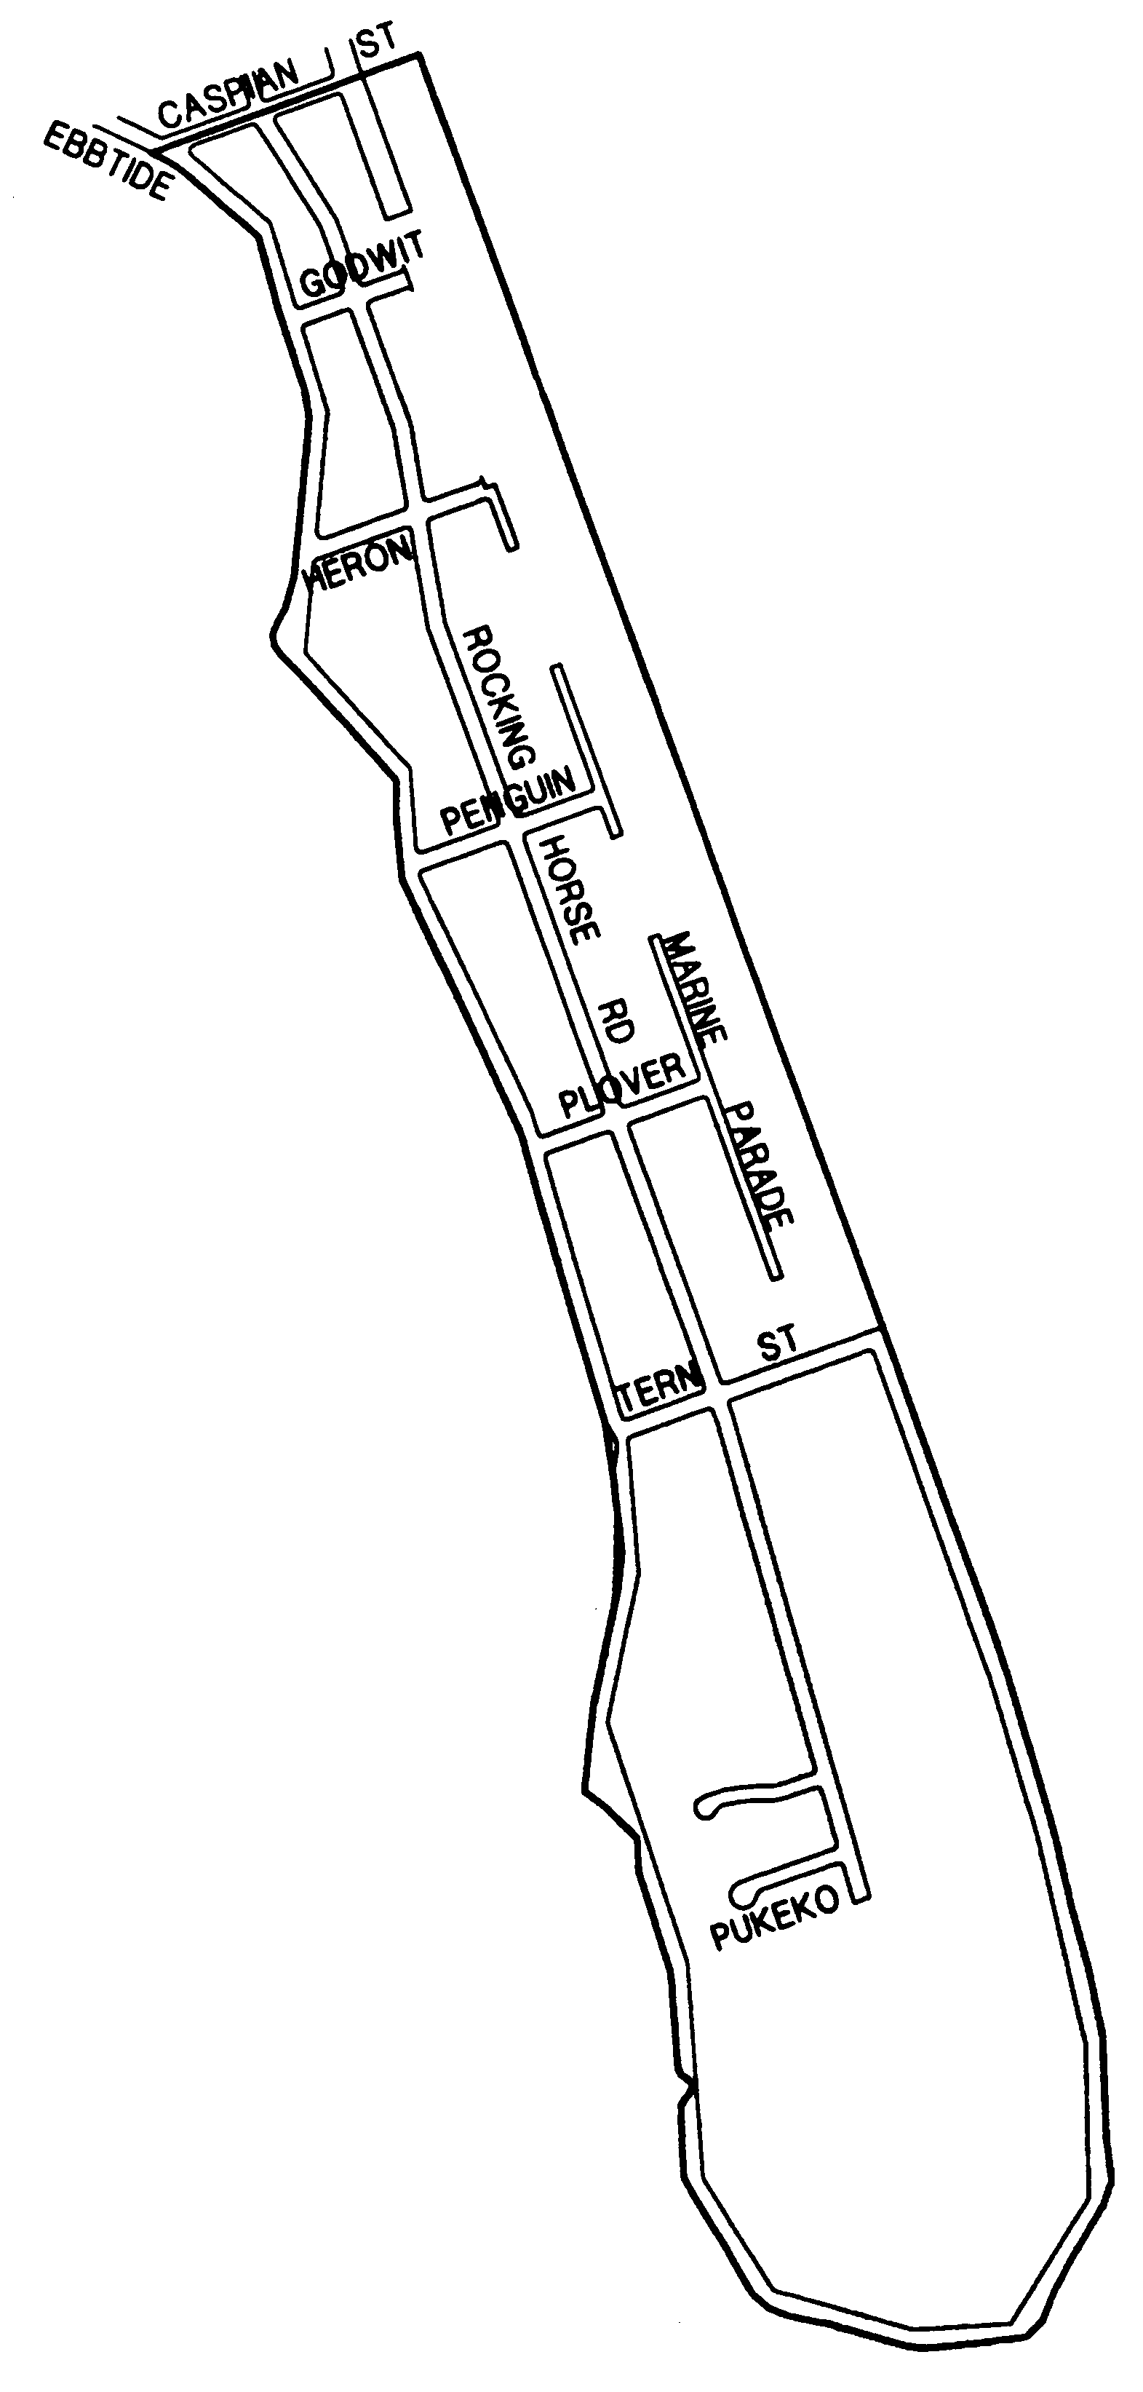

Status: Residents Association – Active
Name: Spencerville Residents Association

No map located on record.
Spencerville Residents Association can be contacted at: spencervilleresidentsassoc@gmail.com
Or via Facebook at: https://www.facebook.com/SpencervilleCommunity/

Status: Residents Association – Active
Name: Waimairi Beach Residents Association

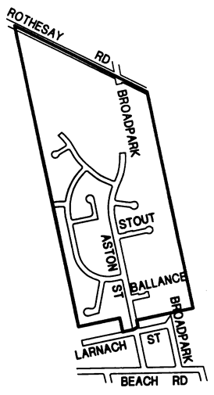

Status: Residents Association - In Recess
Name: Anglesea South Neighbourhood Support

No map located on record.
Email address for group is for a private individual and do not have permission to circulate this.

Status: Residents Association - In Recess
Name: Ascot / Freeville Residents Association

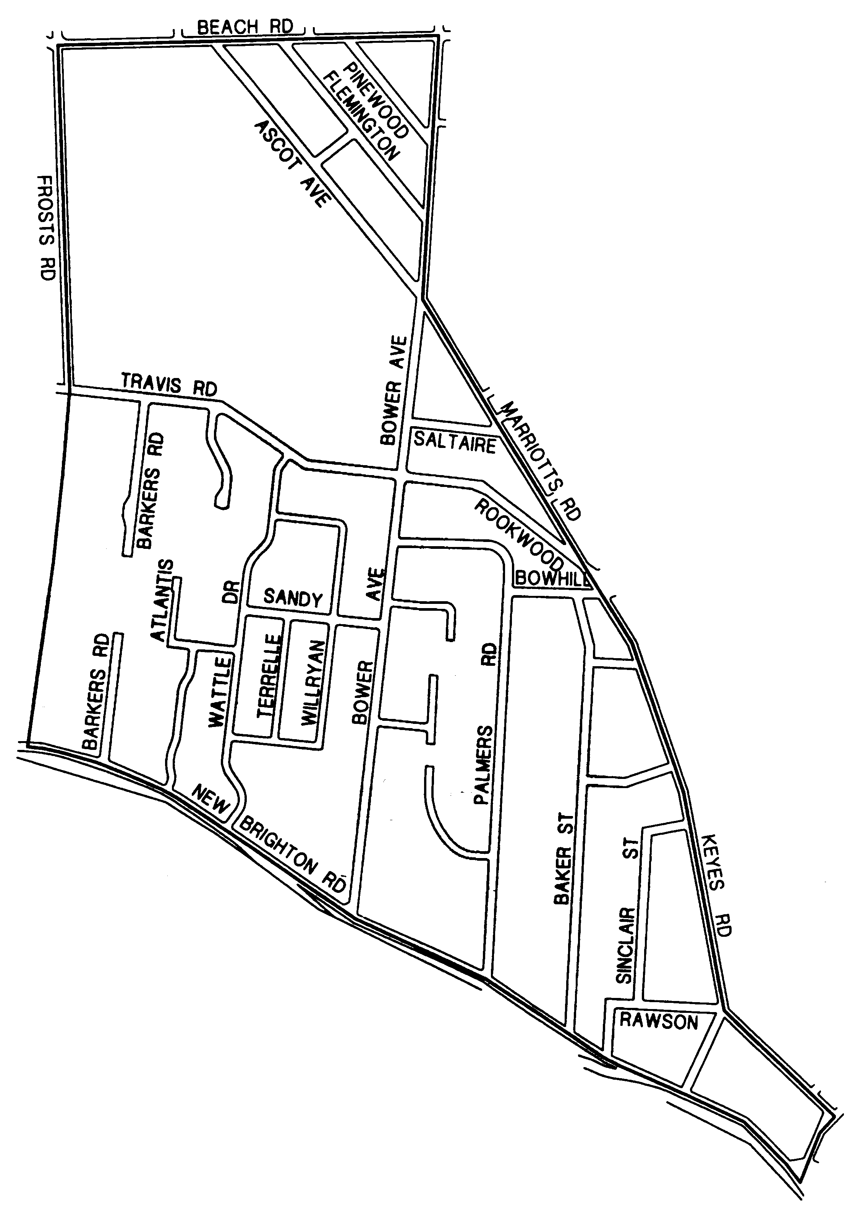

Status: Residents Association - In Recess
Name: Horseshoe Lake Residents Association

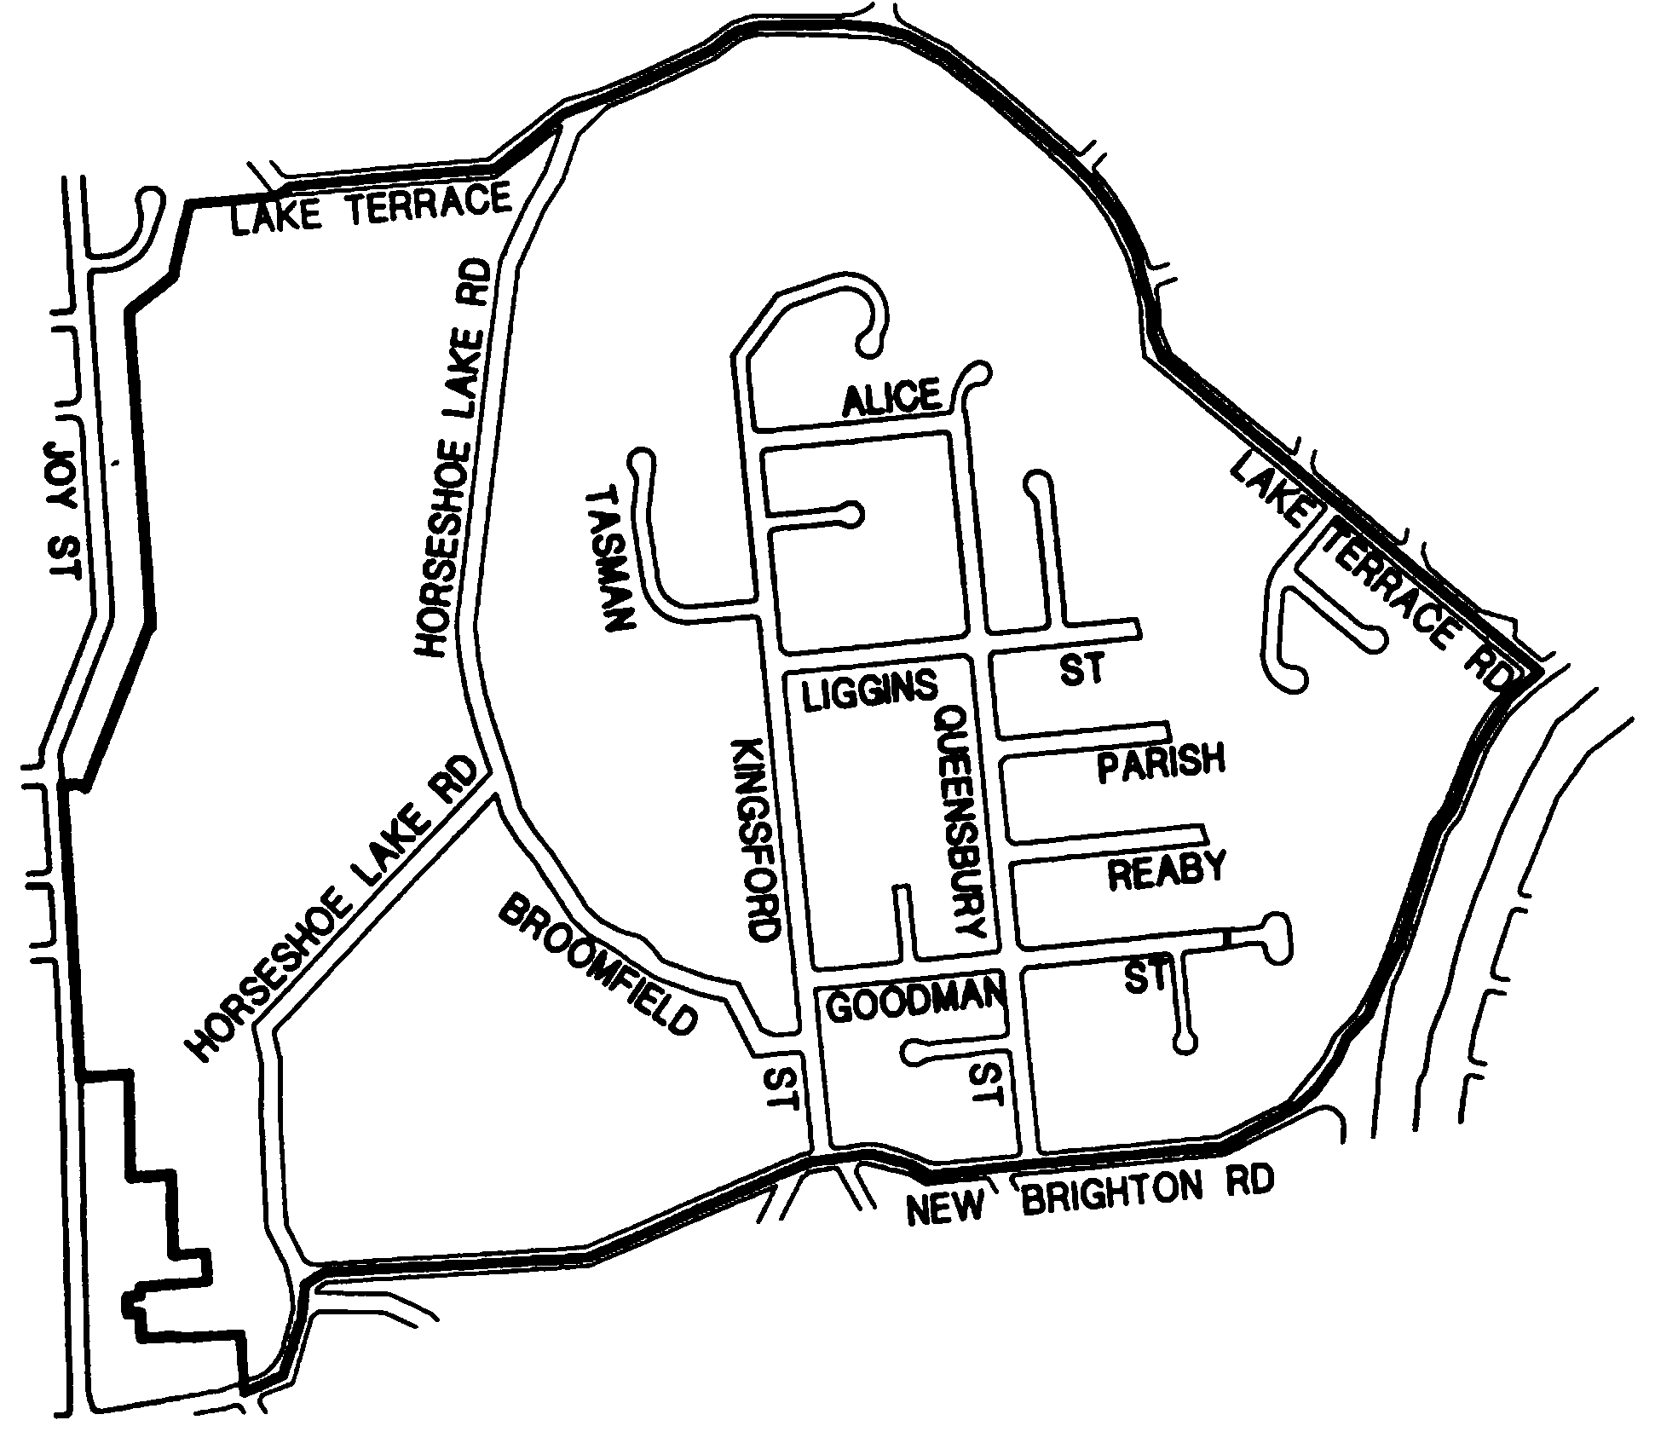

Status: Residents Association - In Recess
Name: Golf Links Residents Association

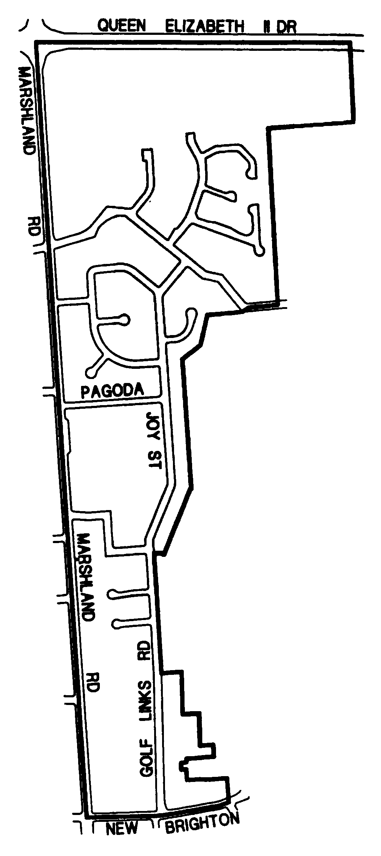

Status: Residents Association - In Recess
Name: Tumara Park Neighbours

No map located on record.
Contact info: https://www.facebook.com/TumaraParkNeighbours/
Believed to be currently operating as an informal group.

Status: Residents Association - In Recess
Name: Waitakiri Residents Association

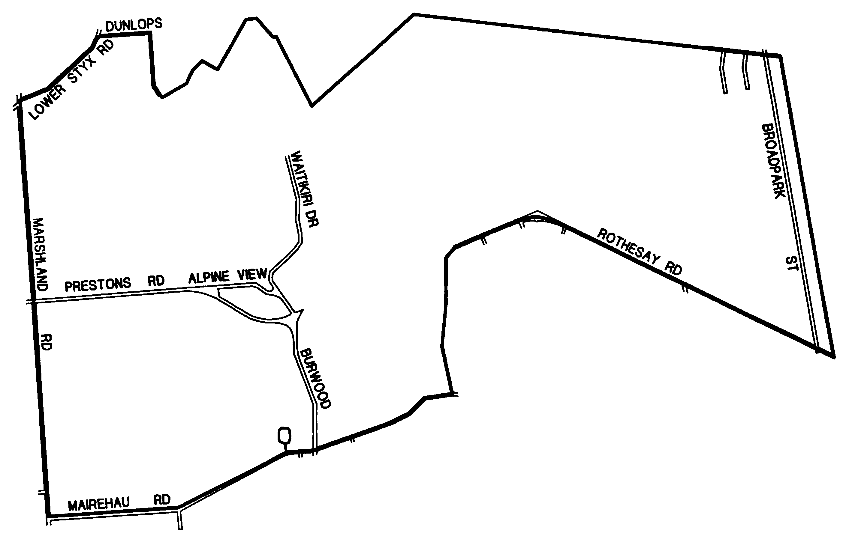

Status: Residents Association - Not Council Recognised
Name: South Brighton Residents Association

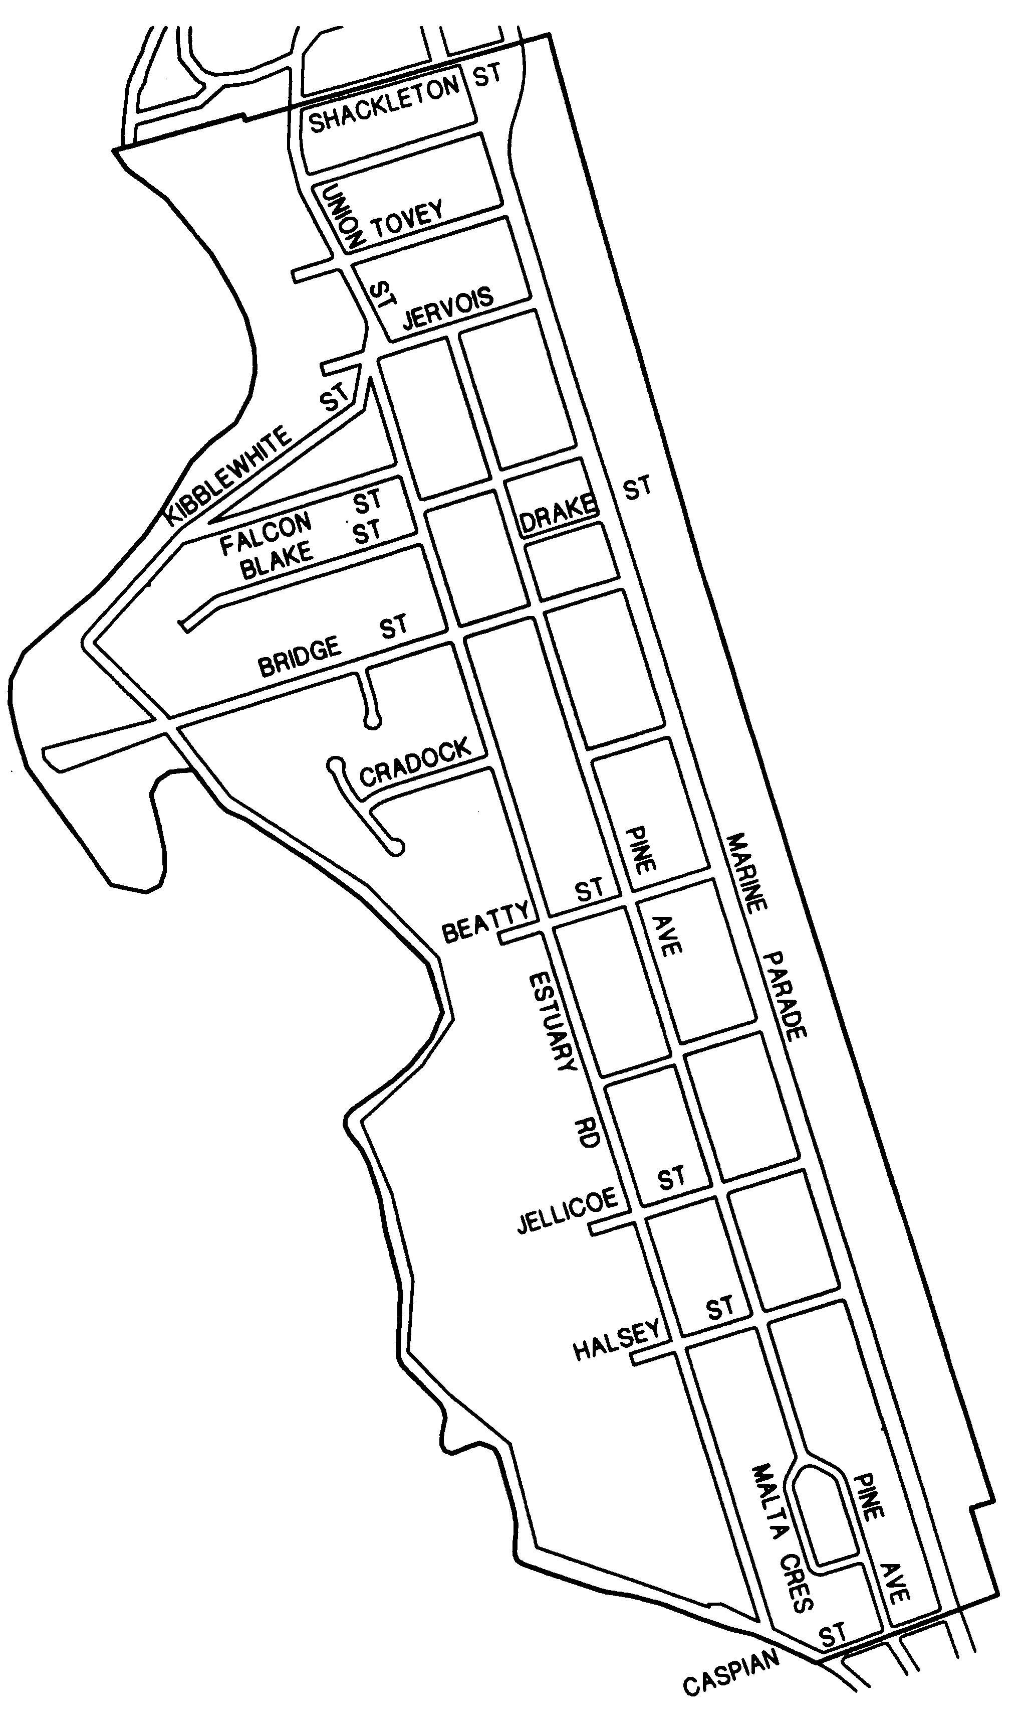

Status: Residents Association - Informal and Not Council Recognised
Name: Avondale Neighbours

As an informal group, no boundary map is available.
No contact information available.

