9 September 2021

**Response IR-01-21-26353**

Amanda Murtagh

[fyi-request-16541-d628a0f1@requests.fyi.org.nz](mailto:fyi-request-16541-d628a0f1@requests.fyi.org.nz)

Dear Amanda

Thank you for your Official Information Act (OIA) request of 28 August 2021 seeking the following:

*When a person makes a personal information request under the Privacy Act 2020 and the Police respond under the Official Information Act 1982, under what circumstances would the Police do that?*

The Police website explains that the Privacy Act enables a person to request information about themselves and they do not have to be a citizen, permanent resident, or be in New Zealand to request it.

If requesting information about third parties, or information owned by someone else for example   
Police instructions, this request is considered under the Official Information Act.

The Acts can overlap because information Police hold about one person can also contain information about another person. The onus is on Police to determine the appropriate Act for the specific information requested, not the requestor.

For further information or to make a request please follow this link <https://www.police.govt.nz/advice-services/request-information>

I trust that you are satisfied with my response. You do of course have the right under section 28(3) of the OIA to ask the Ombudsman to seek an investigation and review of my decision.

Yours sincerely

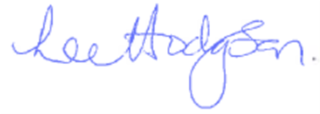  
Lee Hodgson  
**Director Ministerial Services**