15 October 2013

Mr Craig Ryan

fyi-request-1211-a5b330fb@requests.fyi.org.nz

Dear Mr Ryan

Your Official Information Act request to the Minister of Revenue has been transferred to IR under section 17 of the Official Information Act. You requested:

The total amount of penalty interest that has being created and gathered by Inland Revenue for overseas based borrowers since the loan scheme was enacted up until the present.

Is there any evidence that the penalties overburden and prolong repayment of overseas based borrowers?

How much is the largest outstanding overdue debt including and the breakdown of those penalties for an individual overseas based borrower?

We received your request in this office e on 14 October 2013 and will respond by 12 November 2013.

Yours sincerely

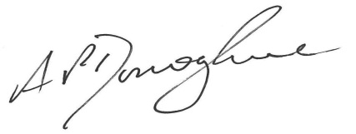

Tony Donoghue
Manager, Commissioner’s correspondence

