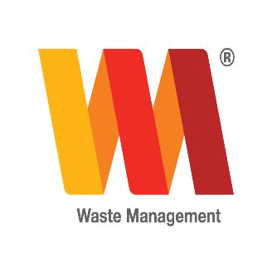
Hutt City Council – Current Recycling Market Environment
Current Setup
There are currently five public recycling stations in the Lower Hutt area: Naenae, Wainuiomata, Wakefield, Kelson and the Seaview Transfer Station. In addition to this, we also have six trucks collecting recycling crates (grades 1-7 plastics and paper bins taking cardboard & paper) from residential addresses in the wider Hutt valley area.
Issues / Problems
Aside from contamination issues, changes are also required due to the dramatic reduction in demand from international recycling markets. We cannot be certain what the plastic market for grade 3-7 plastic will be like in the future, but in the short to mid-term this is not favourable. There is also little real visibility of the end use of this material, so ensuring sound chain of custody has become much more challenging.
Mixed plastic collections
There is a general move afoot to restrict kerbside collections to just PET (No. 1) & HDPE (No. 2), as both grades have maintained fairly good demand, both in NZ and offshore.
Ideally, we would prefer to have only clear PET bottles collected in the No. 1 category.
No. 2 should include clear/natural milk bottles for export or local sale, plus light proof milk bottles and mixed colour (HDPE) janitorial bottles for local sale.
As single product streams these items are able to go direct to a processing plant so confidence in actual end use remains high.
Mixed 1-7
Mixed 1 -7 generally includes coloured PET bottles & mixed colour HDPE janitorial bottles, with clear PET bottles and clear/natural milk bottles having been positively sorted out of this grade.
HDPE “Anchor” (triple layer) light proof milk bottles are not popular with overseas buyers and ideally should not be included in a mixed 1-7 grade.
HDPE is the main item of interest for offshore buyers.
Previously overseas processors buying mixed 1-7 plastics would generally concentrate on sorting grades 1, 2, 5 & 6 which tend to make up the bulk of a 1-7 grade.
There is currently almost no demand for mixed 1-7 grade plastics in Malaysia & Indonesia. Malaysia has just announced a ban on mixed plastic products such as this and Indonesia is not now expected to be far behind.
Mixed 3-7
There is no buyer interest/export market for 3-7 grade and value for this mix of product is now pretty much at $0 with some reports of processors in NZ paying “buyers” to take this product.
There remains a possibility of local market demand developing in the future, however this is seen as being several years away, and likely to have a regional impact rather than full national demand.
Benefits of the Changes
With this change we believe there will be less confusion for the public by knowing which plastics can be recycled. The Council can say to the public with confidence that the majority of plastics 1s-2s are recycled within New Zealand markets in Wellington, Christchurch, Palmerston North and Auckland.

